**Retrospective Analysis of a Natural-Origin Steelhead Population’s Response to Exclusion of Hatchery Fish**

Ian Courter1 and Garth Wyatt2

1Mount Hood Environmental

PO Box 744 Boring, OR 97009

503-663-3697

ian.courter@mthoodenvironmental.com

2Portland General Electric

33831 Faraday Rd. Estacada, OR 97023

503-630-8231

Garth.Wyatt@pgn.com

A retrospective analysis of Upper Clackamas River steelhead population census data was conducted to determine the cause of a notable decline in natural-origin winter steelhead spawner abundance during return years 1972-1998 (Figure 1). It was previously asserted that negative ecological interactions between naturally produced, non-indigenous summer steelhead juveniles and native winter steelhead juveniles reduced the productivity of the winter steelhead population, contributing to the decline in winter steelhead abundance (Kostow and Zhou 2006). If this casual mechanism were accurate, productivity of the winter steelhead population would be expected to increase following hatchery fish exclusion beginning the year 2002 through present. However, winter steelhead abundance in the Upper Clackamas River did not rebound to levels observed during the years preceding hatchery stocking (Figure 1). Instead, fluctuations in winter steelhead abundance continue to be correlated with other regional winter steelhead stocks (Figure 2), as well as sea surface temperature and spill at North Fork Dam, the gateway to the Upper Clackamas Basin (Figure 3). Moreover, our results suggest that winter steelhead productivity was not negatively impacted by the presence of hatchery summer steelhead. When used as a predictive variable in our models, the abundance of hatchery summer steelhead was positively correlated with winter steelhead recruitment (Figure 3), and the choice of model (linear or non-linear) did not alter the positive association of hatchery fish with natural-origin winter steelhead production. The correlation may be explained by hatchery summer steelhead and winter steelhead sharing a common environment during freshwater migration and ocean phases of their life cycle.

Although we used a similar analytical approach, we were unable to replicate the modeling output noted by Kostow and Zhou (2006)[1]. Differences between study findings are likely attributed to the following:

* We utilized ten additional years of spawner-recruit data, adjusted native winter steelhead spawner abundance to account for hatchery broodstock take and presence of hatchery-origin winter steelhead, and adjusted summer steelhead abundance to account for Upper Clackamas River harvest (Figure 1).
* The previous analysis1 reported that over 3000 adult winter steelhead returned in run year 2004, shortly after the exclusion period began. This would be a relatively large return for this population, and was cited as an early indication that the declining trend had reversed. However, the actual number of winter steelhead to return that year was 2110, which was similar to the levels of production observed during the pre-exclusion period.
* In the previous analysis1, hatchery fish were treated as a categorical variable for two periods associated with the presence of “low” (1958-1974, 2000-2001) and “high” (1975-1999) hatchery fish abundance relative to natural-origin fish. Stock-recruitment models were fit to these data and, because winter steelhead productivity declined during the “high” period, it was assumed that hatchery fish were responsible for reducing winter steelhead productivity. However, it appears that environmental factors, particularly ocean conditions, were not adequately accounted for resulting in the hatchery fish categorical variable acting as a proxy for periods of good and bad environmental conditions.
* The previous assessment1 also examined hatchery fish abundance as an interaction variable in models of winter steelhead recruitment. We believe this approach is appropriate for these data; therefore we adopted a similar approach but also chose to evaluate the effects of hatchery fish relative to other important survival covariates.
* Lastly, our assessment included reference populations. There is strong covariation between productivity of contiguous steelhead populations. Therefore, the decline in abundance of natural-origin steelhead in the Upper Clackamas River (1972-1998) was principally driven by environmental factors common to steelhead populations in the Lower Columbia River / Willamette River region.

In our analysis, declines in winter steelhead population productivity resulting from the passing of hatchery fish upstream of North Fork dam were not detectable. Furthermore, after accounting for the influence of ocean conditions, productivity of the Upper Clackamas Basin winter steelhead population remains unchanged relative to Upper Willamette Basin winter steelhead populations despite exclusion of hatchery fish in the Upper Clackamas Basin. This assessment underscores the need for studies that directly quantify the effects of hatchery fish on the production of natural-origin salmon and steelhead.

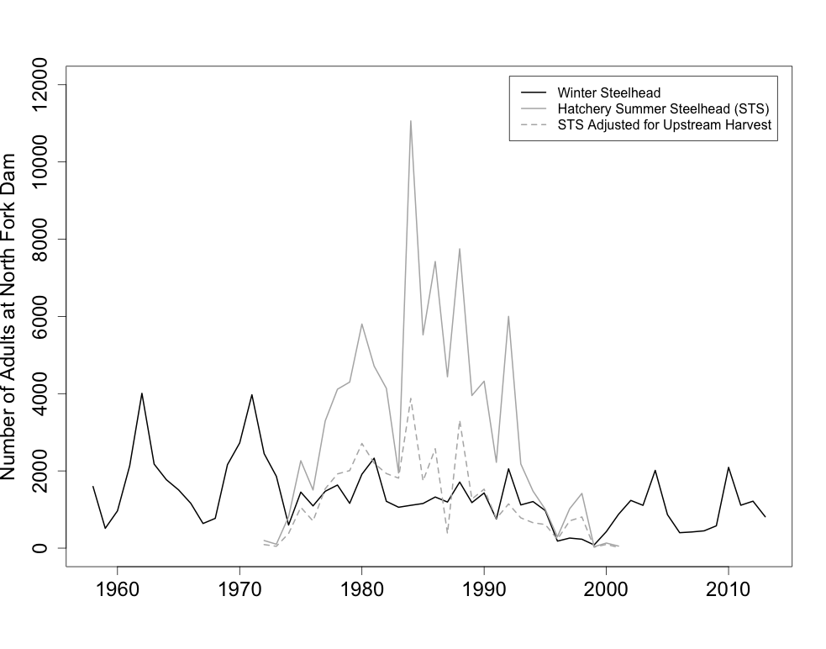

**Figure 1: Annual abundance of natural-origin winter steelhead and hatchery-origin summer steelhead passed upstream of North Fork Dam in the Upper Clackamas Basin, 1958-2013.**

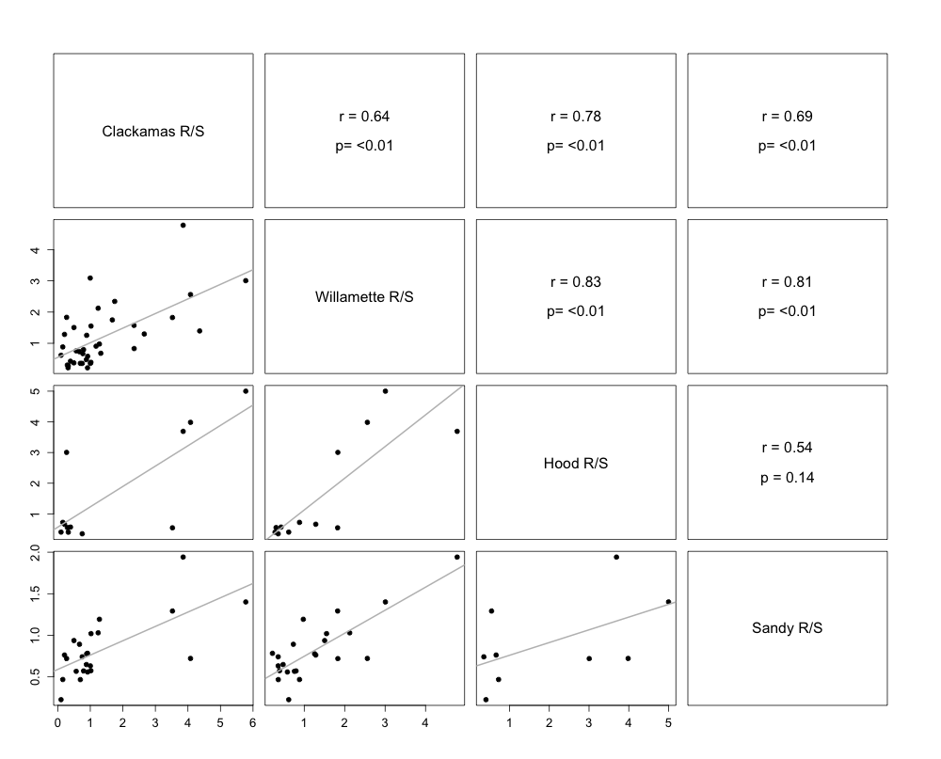

**Figure 2: Productivity (adult recruits per spawner) of winter steelhead populations in the mid-Columbia River region. Clackamas River (1971-2009), Willamette River (1971-2009), Hood River (1992-2004), and Sandy River (1978-2001).**

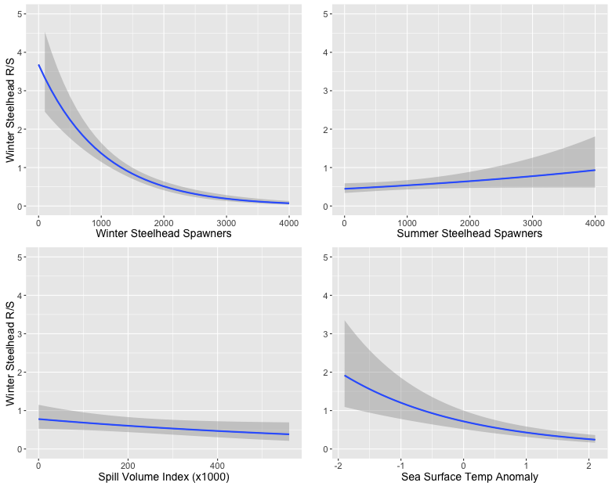

**Figure 3: Influence of winter steelhead spawner abundance, hatchery summer steelhead spawner abundance, spill volume index at North Fork Dam, and sea surface temperature anomaly on linear model predictions of Upper Clackamas River winter steelhead productivity (adult recruits per spawner), 1959-2009.**

1. Kostow KE, Zhou S. 2006. The effect of an introduced summer steelhead hatchery stock on the productivity of a wild winter steelhead population. Transactions of the American Fisheries Society 135(3):825-841.